**SQL ASSIGNMENT-3**

**QUESTIONS:**

**PART-1:**

CREATE TABLE students10 (

student_id INT,

name VARCHAR(50),

course VARCHAR(50),

marks INT,

age INT,

city VARCHAR(50),

scholarship INT

);

INSERT INTO students10 VALUES

(1, 'Ravi', 'Math', 85, 20, 'Chennai', NULL),

(2, 'Priya', 'Science', 92, 21, 'Delhi', 10000),

(3, 'Amit', 'English', 75, 19, 'Mumbai', 5000),

(4, 'Sneha', 'Math', 88, 22, 'Kolkata', NULL),

(5, 'John', 'History', 67, 20, 'Chennai', NULL),

(6, 'Meena', 'Science', 95, 23, 'Delhi', 15000),

(7, 'Karan', 'English', 70, 20, 'Bangalore', 3000),

(8, 'Divya', 'History', 80, 22, 'Mumbai', NULL);

1.Display students with marks between 70 and 90.

2.List students aged between 20 and 22.

3.Find students whose name starts with 'P'.

4.Find students whose city contains 'ai'.

5.Find names where the second character is 'r'.

6.Show top 3 students with highest marks.

7.Show students who have a scholarship.

8.Show students only if there is at least one student from 'Delhi'.

9.Show students with marks greater than ANY student in the 'History' course.

10.Show students with marks greater than ALL students in the 'English' course.

11.Show students in 'Math' course AND age > 21.

12.Show students in 'Science' OR 'English' course.

13.Show students NOT from 'Mumbai'.

14.Show students who don’t have a scholarship.

15.Replace NULL scholarship with 0 using IFNULL.

16.Replace NULL scholarship with 0 using COALESCE.

**ANSWER:**

**PART-1:**

use industry;

CREATE TABLE Products (

product_id INT PRIMARY KEY,

product_name VARCHAR(100),

category VARCHAR(50),

unit_price DECIMAL(10, 2)

);

INSERT INTO Products (product_id, product_name, category, unit_price) VALUES

(101, 'Laptop', 'Electronics', 500.00),

(102, 'Smartphone', 'Electronics', 300.00),

(103, 'Headphones', 'Electronics', 30.00),

(104, 'Keyboard', 'Electronics', 20.00),

(105, 'Mouse', 'Electronics', 15.00);

select* from Products;

select product_name,unit_price from Products;

select * from Products where category ="Electronics";

select product_id,product_name from Products where unit_price >100;

select avg(unit_price) from Products;

select product_name,unit_price from Products where unit_price= (select max(unit_price) from Products);

select product_name,unit_price from Products order by unit_price desc;

select product_name,unit_price from Products where unit_price between 20 and 600;

select product_name,category from Products order by category asc;

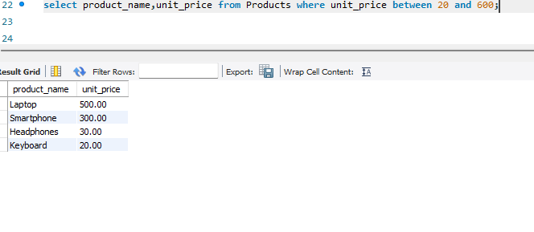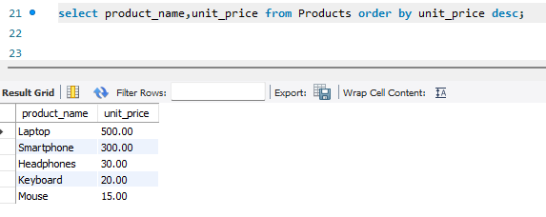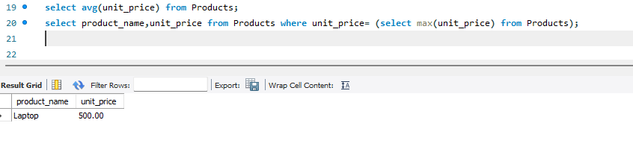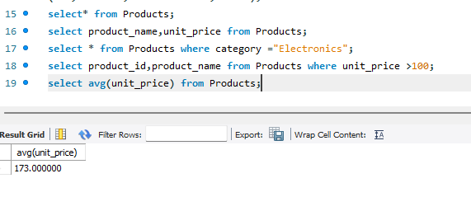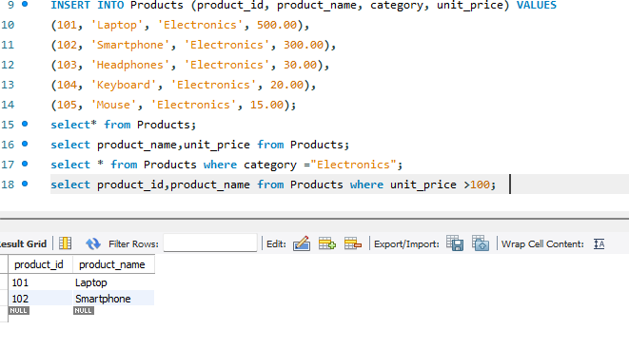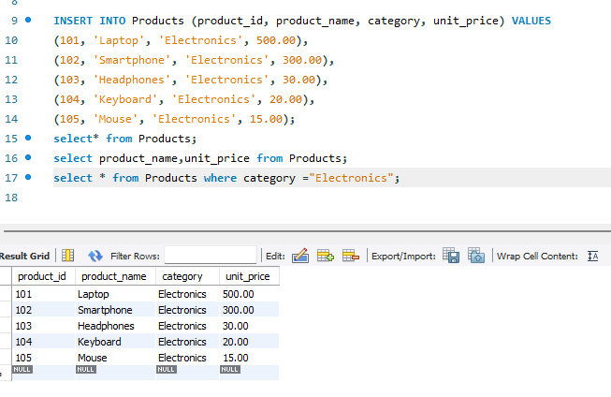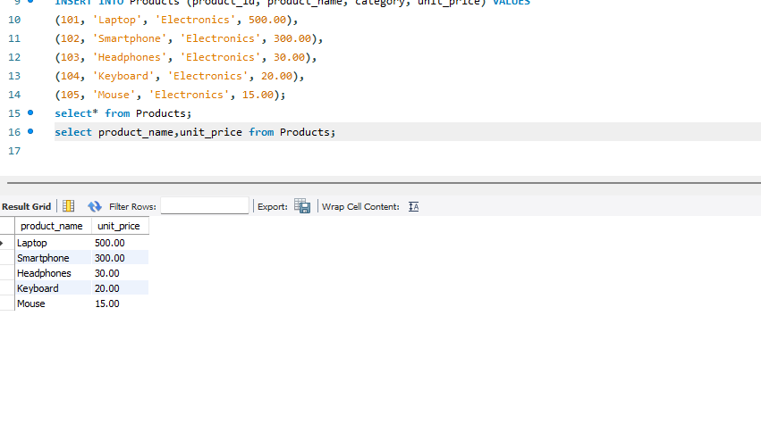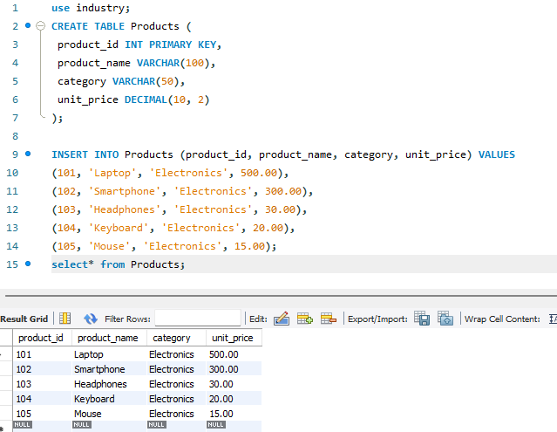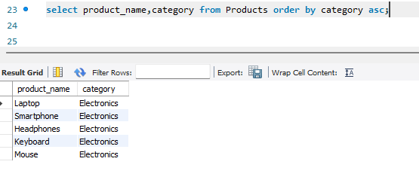

**PART-2:**

CREATE TABLE Sales (

sale_id INT PRIMARY KEY,

product_id INT,

quantity_sold INT,

sale_date DATE,

total_price DECIMAL(10, 2),FOREIGN KEY (product_id) REFERENCES Products(product_id)

);

-- Insert sample data into Sales table

INSERT INTO Sales (sale_id, product_id, quantity_sold, sale_date, total_price) VALUES

(1, 101, 5, '2024-01-01', 2500.00),

(2, 102, 3, '2024-01-02', 900.00),

(3, 103, 2, '2024-01-02', 60.00),

(4, 104, 4, '2024-01-03', 80.00),

(5, 105, 6, '2024-01-03', 90.00);

select*from Sales;

select sale_id,sale_date from Sales;

select sale_id,sale_date from Sales where total_price>100;

select sale_id,total_price from Sales where sale_date="2024-01-03";

select sum(quantity_sold*total_price) as total_revenue from Sales;

select sum(quantity_sold) as total_quantity_sold from Sales;

select sale_id,product_id,total_price from Sales where quantity_sold>4;

select avg(total_price) from Sales;

